1/20 CBASS, Rack 241D should not have PAM values for position 8. There was no 8.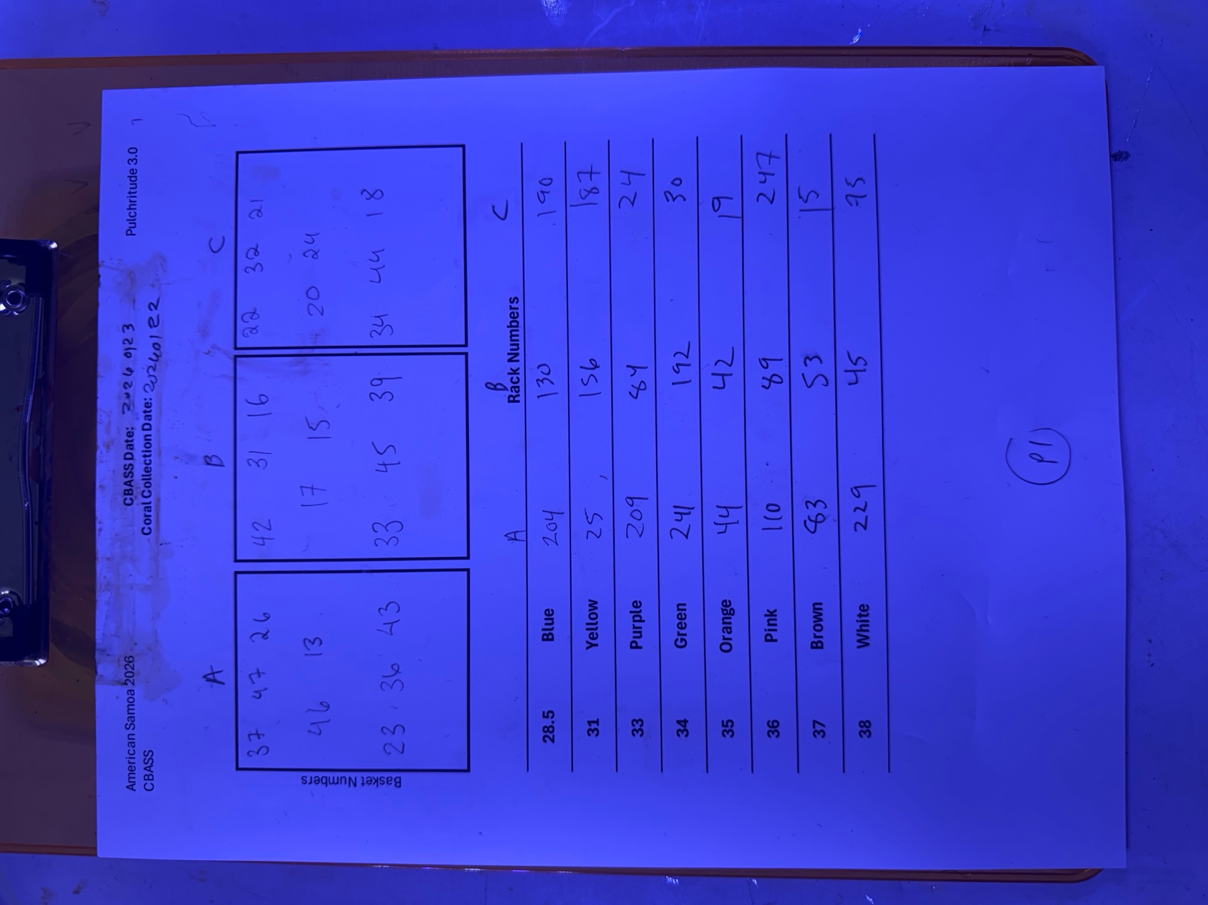
1/23 CBASS, Rack 106E, 16E, 200E, 224E, 248E, 32E, 48E, 58E have no metadata

No Bag## were recorded for collection on 1/22 and cbass on 1/23 so where did they go

